**KBC GAME**  

**Report**

**Prepared by:**

Sanjay kumar praween rajwanshi

2016ucp1382 2016ucp1401

**1.INTRODUCTION**

**1.1. Project Overview**

* This web application provide facility to user to play online KBC GAME.
* This application allows user to play the game and check their prize after the game ended.
* Admin can Manage the user . Admin can add more question to the game at any time.
* New users can register themselves on the portal and take the part in game .

**1.2. Purpose**

* To improve the knowledge of user .
* Responses by the candidates will be checked automatically and instantly.
* Made for fun.

User can check their results just after the game is ended

**1.3. Scope**

This system allows the users to take the online Game and check the success potential.

**2. Functional or Specific requirements**

This web application is for online “objective” quizzes.

Administrator and User should satisfy following requirements:

**Administrator:**

1. Logging into the system.
2. Editing profile.
3. Changing password.
4. Editing of database.
5. Add new admin.
6. Adding the new subjects and tests.
7. Marking correct answers in the given questions.

**User:**

1. Registration on the portal.
2. Logging into the system.
3. Editing profile.
4. Changing password.
5. Selecting the subject and corresponding test.
6. Printing the result at the end of the quiz.
7. Reviewing the questions in the quiz.

**2.1. Technologies required**

These are the technologies for this application.

* HTML, CSS and Basic JavaScript for the front end.
* PHP and MySQL for the back end.

**2.2. Software**

Atom for editing and coding.

Apache XAMPP as web server.

**3. Design:**

3.1. ER Diagram:

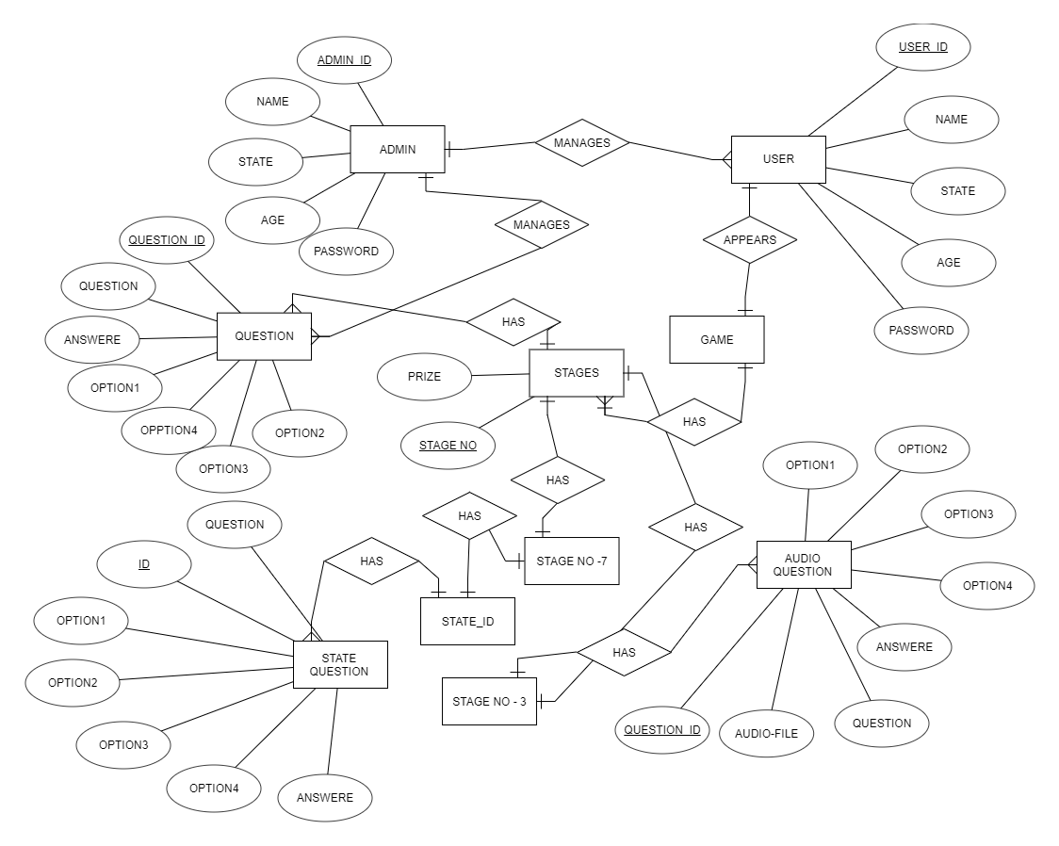

3.2 Database Schema

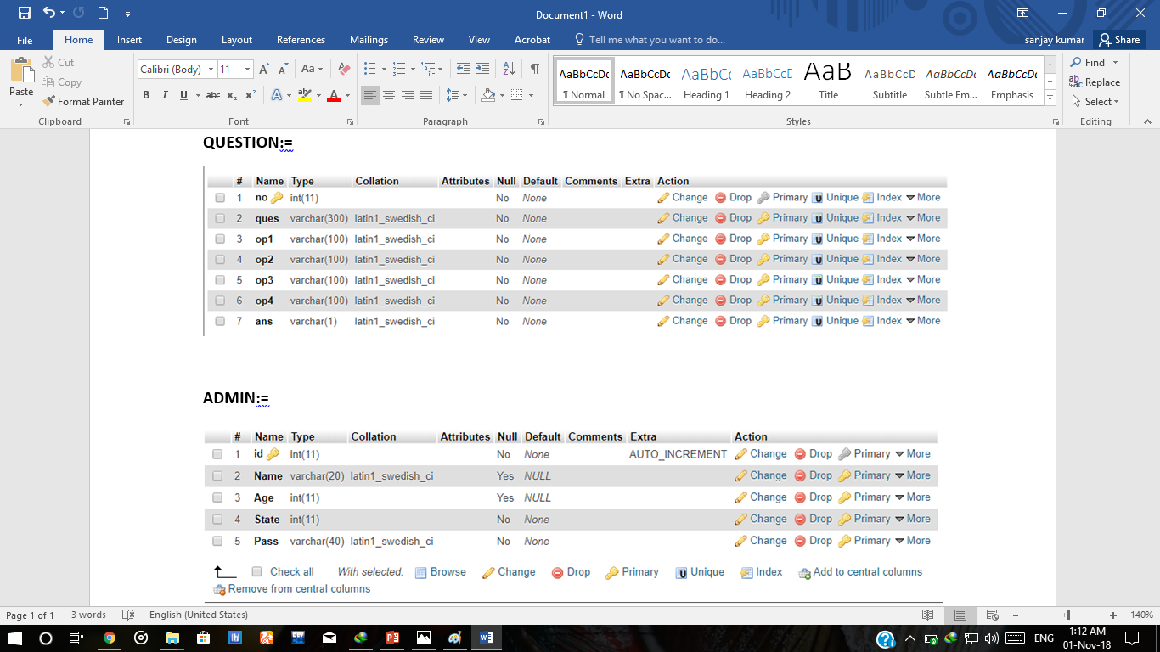

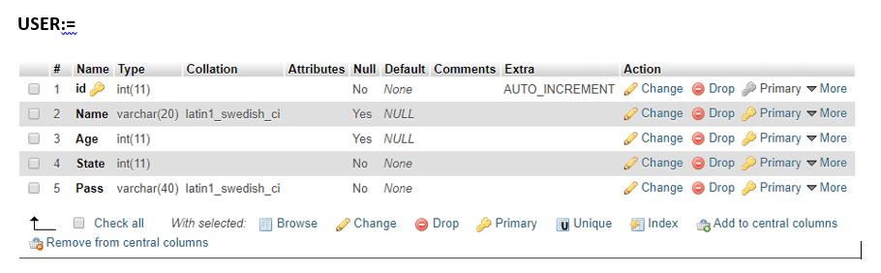

**3.3.Tables**

**Table: QUESTION**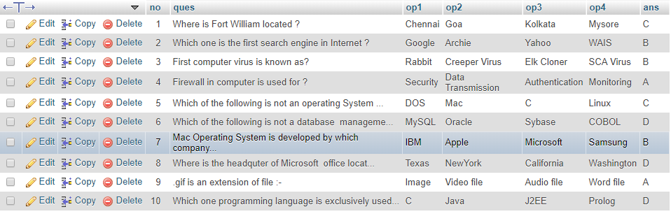

**Table: ADMIN**

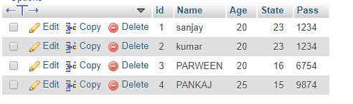

**Table : USER**

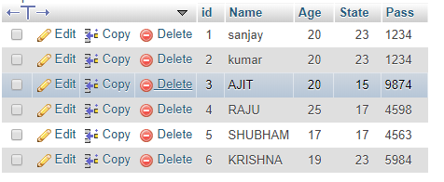

**Normalization of tables:**

**1. admin:**

id -> {pass,name,age,state}

candidate key = id

There is only one FD so table is normalized upto BCNF

**2. user:**

id -> {pass,name,age,state}

candidate key = id

There is only one FD so table is normalized upto BCNF.

**3. question:**

id -> { question, option1, option2, option3, option4, ans}

candidate key = id

There is only one FD so table is normalized upto BCNF.

**4. User Interfaces:**

1.Login interface:

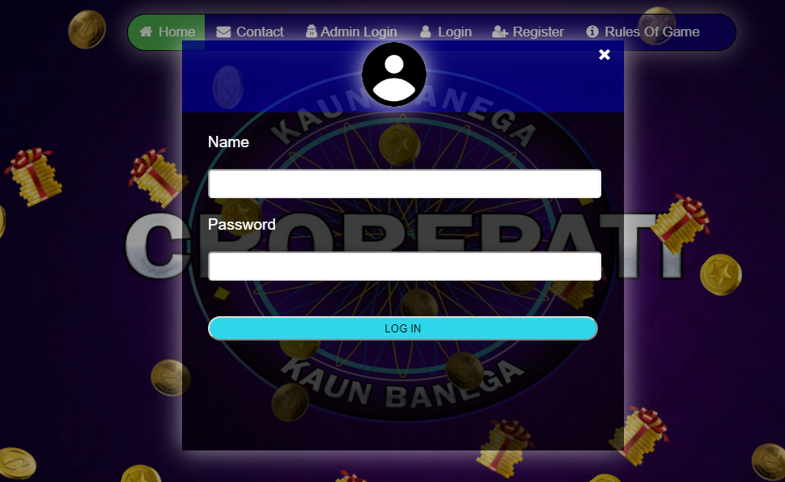

2. Home page:



3.Add new user :

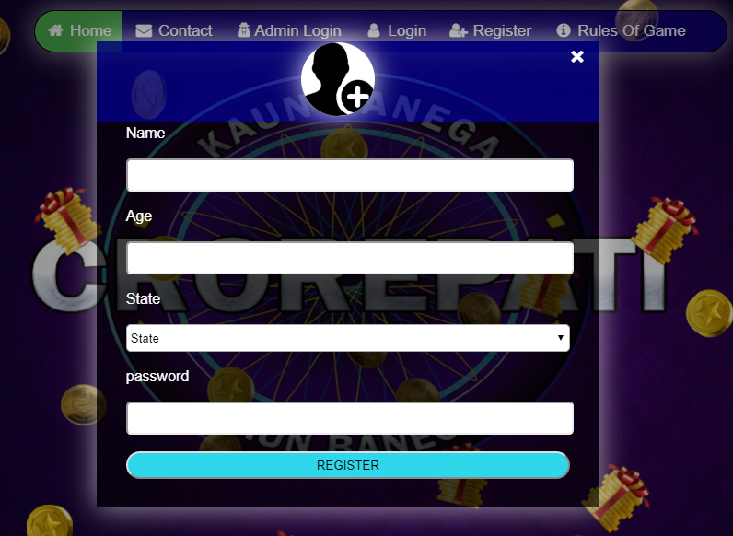

4.Admin Home page:

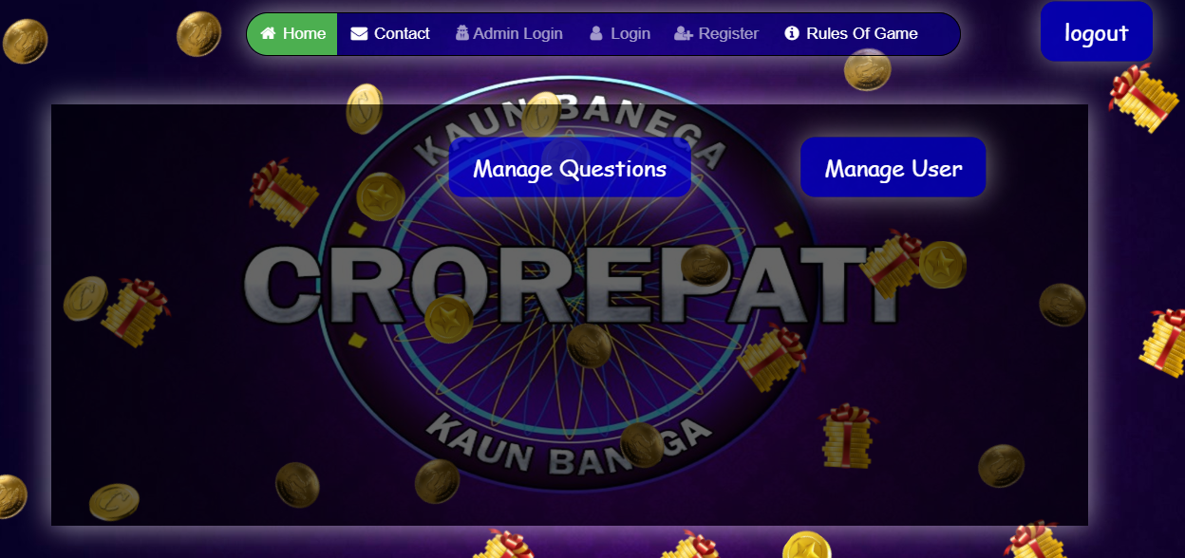

5.Manage Question(admin):

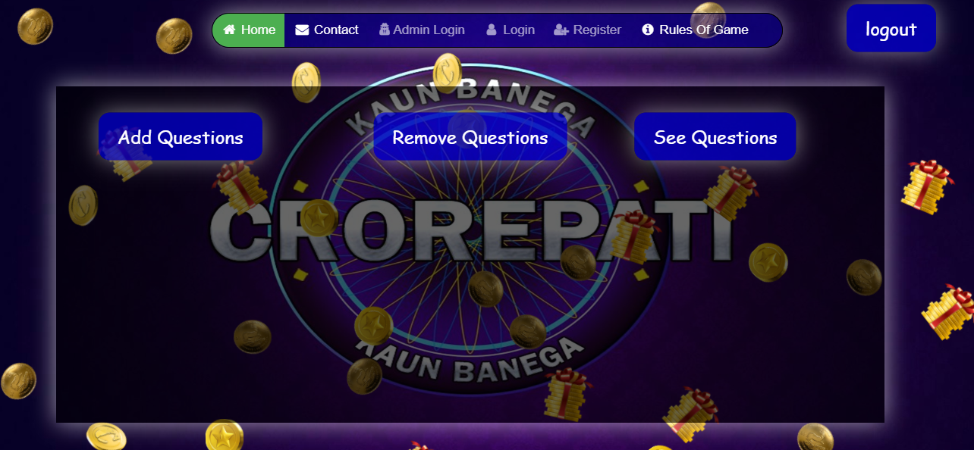

6.Add Question(admin):

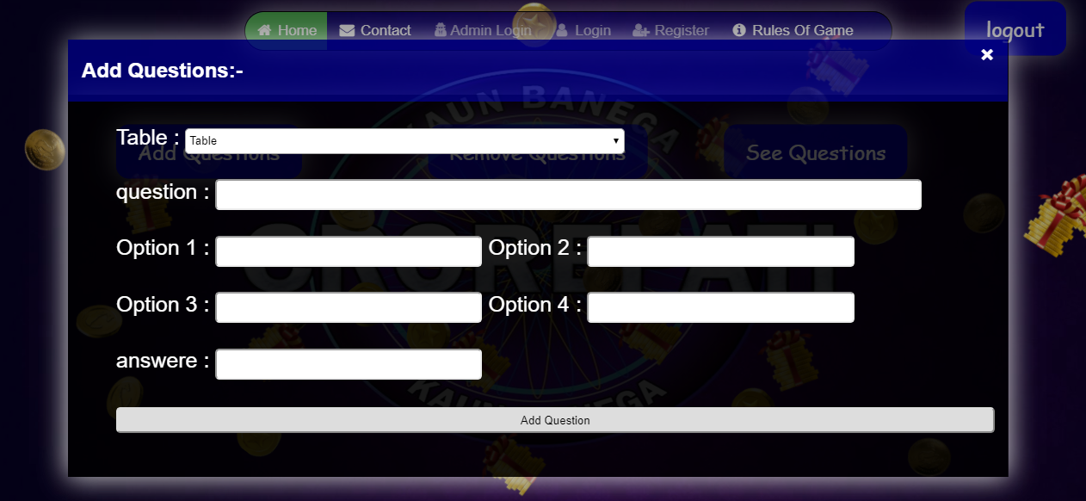

7.Remove Question(admin):

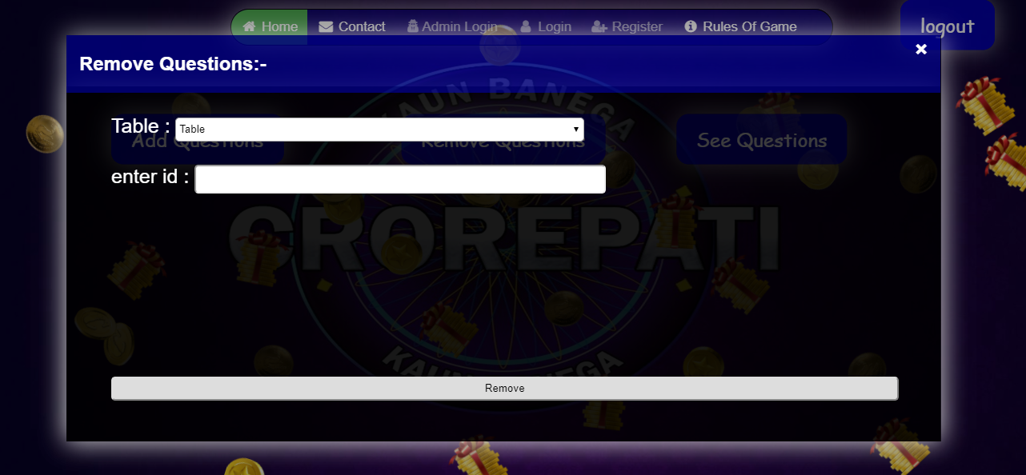

8.See Question(admin):

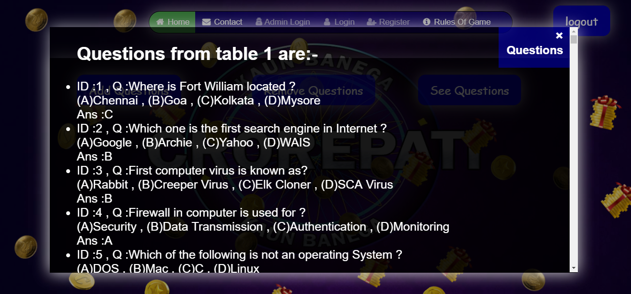

9.Manage Users(admin):



10.See Users(admin):

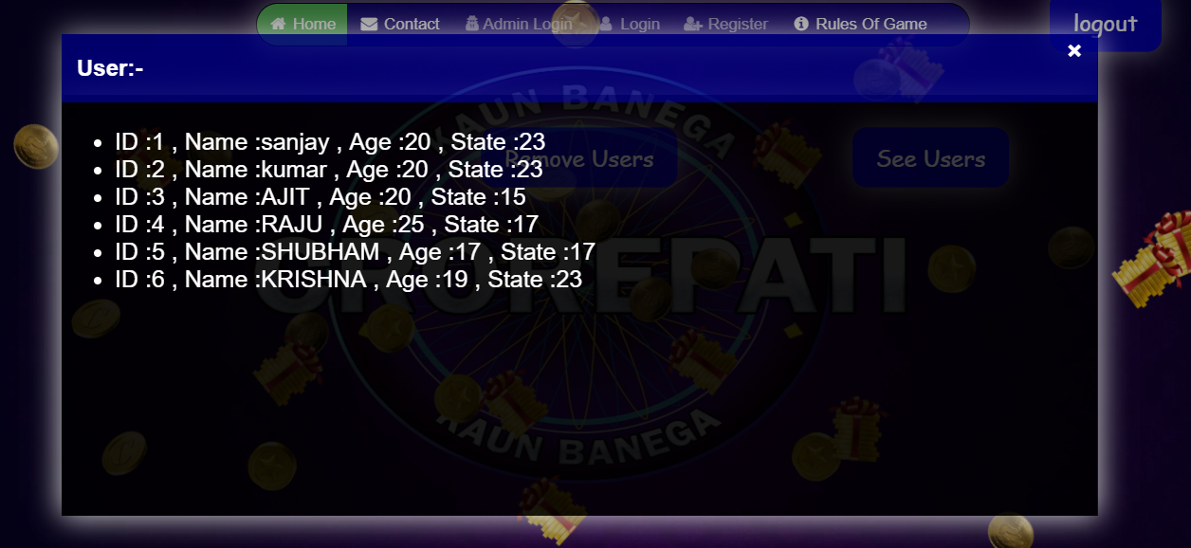

11.User home page:



12.Quiz questions :

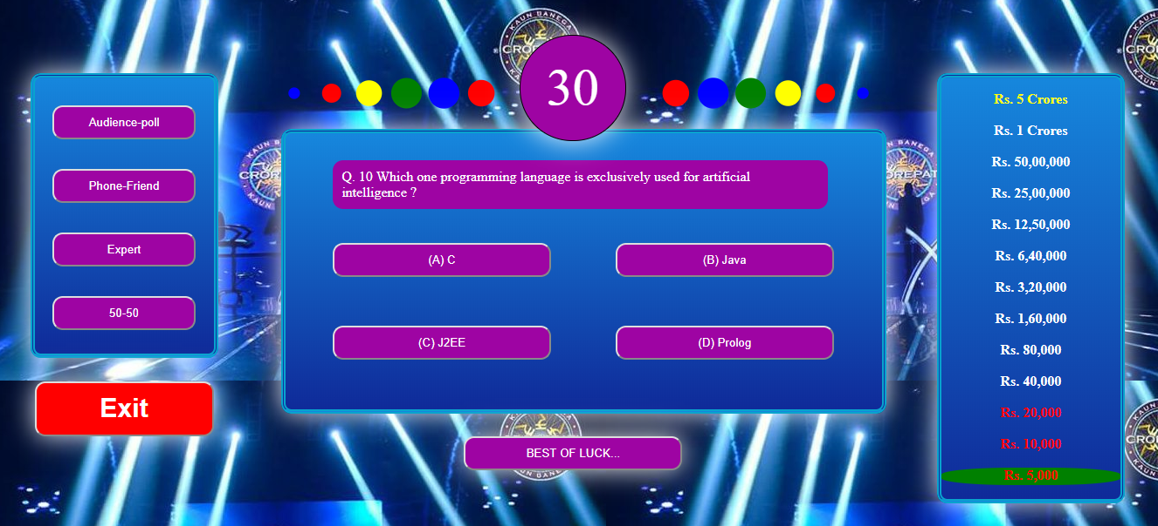

13.Lifeline :

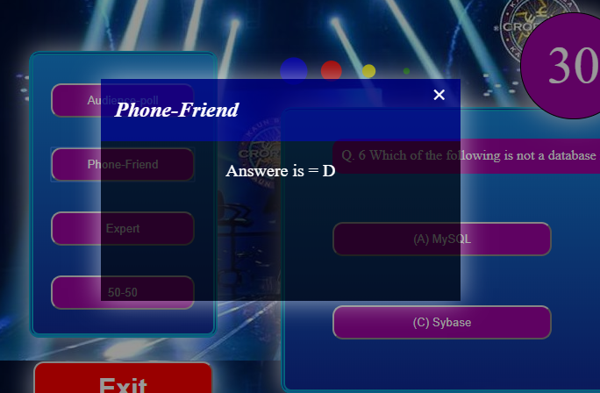

14.Lifeline(used) :

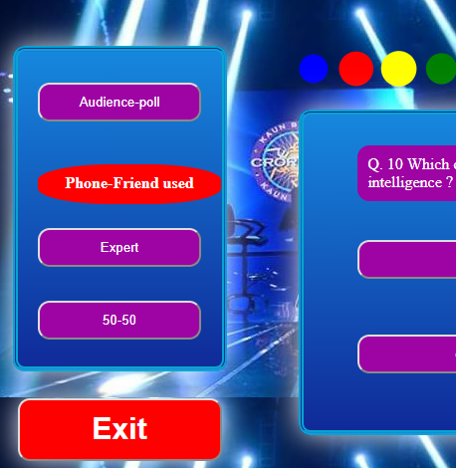

15.prize :

